[**Homework#11**](https://bb-csuohio.blackboard.com/webapps/assignment/uploadAssignment?content_id=_6362379_1&course_id=_168060_1&group_id=&mode=view)

Build the sensor listing app using the code provided. In the homework submission, please include the screenshot for all the sensors that are supported by your phone. Please also show at least three sensors’ capabilities and their values.

Solution:

Code for viewing the list of sensors:

<ListView  
 android:id="@+id/session_list"  
 android:layout_width="fill_parent"  
 android:layout_height="0dip"  
 android:layout_weight="1"  
 android:cacheColorHint="@android:color/transparent"  
 android:dividerHeight=".5dip" />

Once clicked on particular sensor, it will be redirected to that sensor’s capabilities, code for that is:

<TextView  
 android:id="@+id/sensorname"  
 android:layout_width="wrap_content"  
 android:layout_height="wrap_content"  
 android:layout_marginLeft="10dp"  
 android:layout_marginTop="10dp"  
 android:text="Sensor Name"  
 android:textColor="@android:color/black"  
 android:textSize="18sp"  
 android:textStyle="bold" />

To get values of each sensors and its capabilities:

<TextView  
 android:id="@+id/sensorname"  
 android:layout_width="wrap_content"  
 android:layout_height="wrap_content"  
 android:layout_marginLeft="10dp"  
 android:layout_marginTop="10dp"  
 android:text="Sensor Values"  
 android:textColor="@android:color/black"  
 android:textSize="18sp"  
 android:textStyle="bold" />

Screenshots:

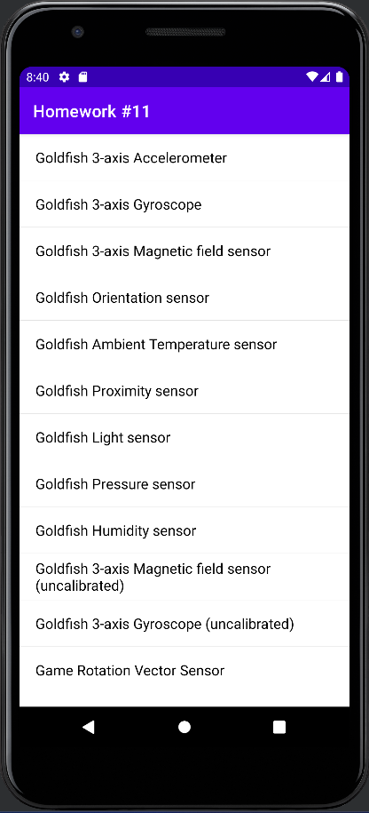

List of sensors

Example of 3 sensors and its values

